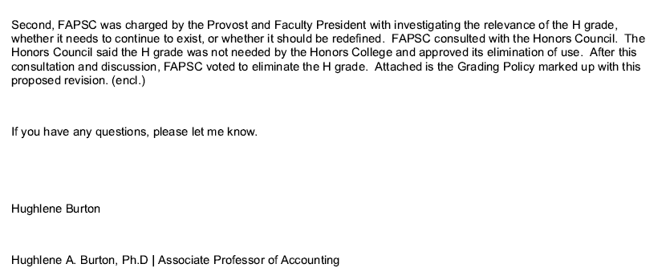

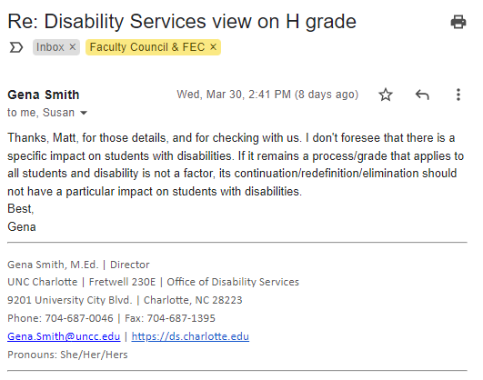

UNC CHARLOTTE ACADEMIC POLICY AND PROCEDURE: GRADING (UNDERGRADUATE)

I. Executive Summary
This policy and procedure guides all aspects of grading. The specific policy on Grade Replacement was revised and this policy reflects new guidance that begins Fall 2021.

II. Policy and Procedure Statement
Instructors assign grades on the basis of their evaluation of the academic performance of each student enrolled in their courses. At the end of the term, the grades are reported to the Office of the Registrar which is responsible for maintaining student academic records and making grades available to students.

Grades
Letters are used to designate the quality of student academic achievement.
UNDERGRADUATE GRADES
Letter | Meaning | Grade Points Per Credit Hour
A | Excellent | 4
B | Good | 3
C | Fair | 2
D | Passing | 1
F | Failing | 0
FX | Academic Dishonesty Violation | 0
I | Incomplete | *
IP | In Progress | *
W | Withdrawal | *
WE | Withdrawal with Extenuating Circumstances | *
AU | Audit | *
NG | Temporary Unreported Grade | *
NR | No recognition given for audit | *
 | Cooperative Education
S | Satisfactory | *
U | Unsatisfactory | *
 | Pass/No Credit
P | Passing | *
N | No Credit | *
* Not used in computation of grade point average
Grades of FX (Academic Dishonesty Violation)
For details on the use of the UX grade, please see University Policy 407, Code of Student Academic Integrity, Section IV - Penalties.
Grade of I (Incomplete)
The grade of I is assigned at the discretion of the instructor when a student who is otherwise passing has not, due to circumstances beyond their control, completed all the work in the course. The missing work must be completed by the deadline specified by the instructor, and no later than 12 months. If the I is not removed during the specified time, a grade of F, U, or N, as appropriate is automatically assigned. The grade of I cannot be removed by enrolling again in the same course, and students should not re-enroll in a course in which they have been assigned the grade of I.
Grade of IP (In Progress)
The grade of IP is based on coursework for courses that extend over more than one semester. For example, a course that requires enrollment for two consecutive semesters would be eligible for an IP grade in the first term (i.e., Undergraduate Senior Project). A grade of IP should not be given for coursework to be completed in one given term. It cannot be substituted for a grade of I. The IP grade expires after six years, and if no final grade has been awarded by that time, the IP grade will default to a grade of N (no credit).
Grade of W (Withdrawal) or WE (Withdrawal with Extenuating Circumstances)
No grade will be given for a course dropped on or before the last day to drop a course without record. After this period, students may only withdraw from a course in accordance with the conditions and deadlines in the Withdrawals policy. Students who withdraw without extenuating circumstances will receive a grade of W and are allowed no more than 16 credit hours of W grades over their academic careers. Students who withdraw under formally recognized extenuating circumstances will receive a grade of WE, indicating that the withdrawn hours do not count against the student’s W-limit hours. Post-deadline withdrawal is only allowable for recognized extenuating circumstances. Unsatisfactory academic performance itself is not an extenuating circumstance. The grade of W or WE is posted on the academic transcript.
Pass/No Credit Option
Every student will be permitted during their undergraduate years to select up to a total of four courses (at most one per academic year) in which they can receive an evaluation of H (honors), P (pass), or N (no credit). This option is designed to encourage curiosity, exploration, and experimentation in areas where a student has strong interest but little or no previous experience. The Pass/No Credit option only applies to courses normally graded on an A-F scale, and it cannot be used on courses taken by a student for credit toward their major or minor or to satisfy University General Education requirements. [Note: courses designated by the faculty to be graded on a Pass/No Credit basis may count for the major.] To exercise this option, the student must declare their intention to take a Pass/No Credit option by completing an Academic Petition by the withdrawal deadline for the term. The deadline is available on the Academic Calendar. This petition requires the approval of the student’s advisor, major department chair, and college associate dean. Courses completed with the grade of Honors or Pass will count toward the hours needed for graduation, but they will not be considered in the computation of the grade point average.

Unsatisfactory Grade Reports
Unsatisfactory Grade Report notifications are sent via email to students in the middle of each semester for courses in which the student is performing below average and a grade has been reported. Students should also seek feedback from instructors. Unsatisfactory grades are available through the secure student access pages of My UNC Charlotte online at my.charlotte.edu.

Final Grades
Final grades are available through the secure student access pages of My UNC Charlotte online at my.charlotte.edu.
Final Grade Changes and Appeals From Final Course Grades
When a final course grade other than Incomplete (I) is officially reported by the instructor at the end of an academic term, the grade is recorded by the Office of the Registrar and can be changed only if the grade has been assigned arbitrarily or impermissibly as defined in University Policy 410, Policy and Procedures for Student Appeals of Final Course Grades.
Students should follow the procedures outlined in the policy if they believe that the final course grade that has been assigned is incorrect. The policy requires the student to discuss the grade with the instructor as soon as possible after the grade is received. Students should note, however, that the University is not obliged to respond to a grade appeal unless the student files it with the appropriate department chairperson or interdisciplinary program director within the first four weeks following the last day of the regular semester or the summer term in which the grade was received. When a grade is assigned consistent with University policy, only the instructor has the right to change the grade except as provided in the Incomplete grade policy. When an instructor reports a grade change for a grade other than I, the “Change of Grade” form must be approved by their department chair and college dean, or the assigned designee of the department chair and/or college dean.

Repeating Courses
A student may receive credit for a course one time only, unless the course description specifies that it “may be repeated for credit.” However, subject to College or program restrictions, students can repeat a previously completed course to earn a higher grade. A student seeking to repeat a course for which they have already earned credit (earned a passing grade) must receive a Repeat Course Override. A Repeat Course Override requires approval of the student’s advisor, department chair, and dean.
Grade Replacement will automatically be applied for the first two courses (maximum of 8 credit hours) repeated where the previous grade earned was a C or below. Under Grade Replacement, both grades earned for the course will be reflected on the transcript. However, only the higher of the two grades for the course will be used in GPA calculations. For any course repeated without Grade Replacement, the most recent grade earned will be used for prerequisite purposes and ALL GRADES earned for the course will be reflected on the transcript and will be used in overall GPA calculations.
Grade Replacement will not be applied to:
- Any course repeated where the previous grade was earned prior to Fall 2007
- Any course other than the first two courses repeated where the previous grade earned was a C or below
- Courses that may be repeated for credit, except for special topics courses where the student is enrolled in the same topic for which they originally received the grade to be replaced
- Courses for which the initial grade was received owing to an admitted or adjudicated academic dishonesty violation (this exception is not subject to appeal or academic petition)
For Grade Replacement to apply, the course to be repeated and the repeat course must have their grades assigned by UNC Charlotte. Grade Replacement will not be processed after a student graduates.
When the course being repeated is a course with an associated lab, the lecture and lab must be repeated concurrently to only consume one of the two allowable grade replacements.
If a student is repeating a course where Grade Replacement would have applied and the student withdraws from the course or from the University, the previous final course grade will be the grade of record for the course and not a W. Any such withdrawal still consumes one of the two grade replacements permitted under this policy. However, a course that is dropped before the end of the Add/Drop period or a course for which the student receives a WE (withdrawal with extenuating circumstances) does not consume one of the allotted replacements.
Students will be notified after the last day to add or drop a course for the term or half-term about any grade replacements in effect for that term or half-term. Students wishing to opt out of using a grade replacement must comply as instructed by the Office of the Registrar and by the withdrawal deadline for the term or half-term. They must similarly comply with the instructions provided and by the withdrawal deadline if they wish to apply grade replacement to a different course being repeated during the same term.
Note: Since credit hours can be awarded only once for a course, repeated courses can affect athletic eligibility, academic standing, veteran’s benefits, and financial aid status.

Credit Hours
Credit hours are the number of hours the course is allocated. The majority of undergraduate courses have three (3) credit hours, while labs and other courses may have one, two, four, or more credit hours. Attempted, passed, and earned credit hours are reported on transcripts. Refer to example below.

Quality Points
Quality points, also known as grade points, are determined by multiplying the number of points assigned to each grade (A = 4, B = 3, C = 2, D = 1, F = 0) by the number of credit hours associated with that course. Refer to the example below.

GPA Hours
GPA hours, also known as quality hours, are the total number of credit hours in the graded courses the student has attempted, except for those for which a grade of I, IP, W, P, AU, or N is recorded. Refer to the example below.

Grade Point Average (GPA)
The grade point average for an undergraduate student is determined by adding all accumulated quality points together, and then dividing by the total number of GPA hours the student has attempted, excluding those for which the student received a grade of I, IP, W, WE, H, P, AU, or N. In computing the grade point average, only those credits attempted at UNC Charlotte or through the Greater Charlotte Consortium (GCC) are included. Refer to the example below.
Example of Transcript:
Subject | Course | Grade | Credit Hours | Quality Points
AMST | 2050 | P | 3.00 | 0.00
CHEM | 1251 | F | 3.00 | 0.00
CHEM | 1251L | F | 1.00 | 0.00
ENGR | 1201 | C | 2.00 | 4.00
LBST | 2101 | C | 3.00 | 6.00
MATH | 1241 | C | 3.00 | 6.00
WRDS | 1101 | B | 3.00 | 9.00
Term Totals (Undergraduate)
 | Attempt Hours | Passed Hours | Earned Hours | GPA Hours | Quality Points | GPA
Current  Term | 18.00 | 14.00 | 14.00 | 15.00 | 25.00 | 1.66
Cumulative | 18.00 | 14.00 | 14.00 | 15.00 | 25.00 | 1.66
Example of GPA Calculation:
GPA = Quality Points/GPA Hours; 25/15=1.66

Grade Point Average Calculator
To calculate grade point averages, visit the online GPA Calculator.

III. Definitions
- Department chair – The faculty member in charge of an academic department of the University.
- Registrar – The official at the University who is responsible for maintaining student records. The Office of the Registrar plans and oversees registration, academic record maintenance, transcript preparation, graduation, a degree audit report system, and curricular records.
- My UNC Charlotte – One-stop shopping for student services via the Web. It combines various systems, user interfaces, and technical solutions already available to the UNC Charlotte community in a single, consistent web-based interface. Students should use My UNC Charlotte at my.charlotte.edu to access web-enabled student services, course information, e-mail, and calendar scheduling.

IV. Policy and Procedure Contact(s)
- Authority: Faculty Council [Faculty Academic Policy and Standards Committee]
- Responsible Office: Office of the Provost and Vice Chancellor for Academic Affairs
- Additional Contact(s): Office of the Registrar

V. History
- December 6, 1967: Policy approved
- November 2, 1989: Revised
- August 15, 2009: Revised [language changes and inclusion of transcript example]
- September 26, 2013: Revised [inclusion of assigned designee of the department chair and/or college dean for approvals of final grade changes]
- February 20, 2014: Revised [added grade of WE and updated Grade of W wording for new Withdrawals policy]
- March 17, 2016: Revised [Add/Drop period changed from 8 instructional days to 8 calendar days for Fall & Spring semesters, effective Fall 2016]
- May 10, 2017: Revised [under "Without Grade Replacement," added information and link about repeat overrides and changed how Grades of D are handled]
- June 30, 2017: Revised [clarified "Grade Replacement" deadline]
- October 19, 2017: Revised [Pass/No Credit period changed from 8 calendar days to 6 business days for Fall & Spring semesters, and to 2nd business day for Summer sessions]
- June 22, 2018: Revised [added FX grade and definition]
- April 18, 2019: Revised [revised language under "Repeating Courses," effective Fall 2020]
- April 9, 2020: Revised [exception for Spring 2020 passed by FEC]
- May 4, 2020: Revised [added NG grade]
- May 6, 2020: Revised [extended implementation date from Fall 2020 to Fall 2021 for new grade replacement procedures under "Repeating Courses" due to COVID-19]
- November 6, 2020: Revised [exception for Academic Year 2020-2021 (Fall 2020, Spring 2021, Summer 2021) passed by FEC]
- December 11, 2020: Revised [added H grade to be is used to indicate a high pass during the 2020-2021 academic year due to the COVID-19 pandemic]
- August 16, 2021: Revised [new grade replacement procedures previously approved implemented for Fall 2021 after delay]
- October 28, 2021: Revised [Changes to the Pass/No Credit option were made to align with revisions made to the Registration policy.]
- December 21, 2021: Revised [Updated Pass/No Credit option to "This petition requires the approval of the student’s advisor, major department chair, and college associate dean" per Registrar's Office]
- January 18, 2022: Revised [Shortened GPA figures to only two digits from three digits after decimal per Registrar and Assistant Provost]

VI. Related Policies, Procedures, and Resources
- Academic Calendar  - Academic Petition Form  - Final Grading Instructions  - Grade Point Calculator  - Grading Policy (prior to Fall 2021)  - My UNC Charlotte  - New Grade Replacement Process Quick Reference Guide [Fall 2021]  - Policy and Procedures for Student Appeals of Final Course Grades  - Request for Review of a Final Course Grade Guidelines for Students  - Repeat Course Overrides  - Satisfactory Academic Progress  - Withdrawals | COVID-19 EXCEPTIONS  Academic Year 2020-2021 (Fall 2020, Spring 2021, Summer 2021)  - Academic Honors Policy Exception for Academic Year 2020-2021 (COVID-19)  - Grading Policy Exception for Academic Year 2020-2021 (COVID-19)  - Amendment to Grading Policy Exception (includes H grade designation)  - Grading Policy Exception FAQs  Spring 2020  - Academic Honors Policy Exception for Spring 2020 (COVID-19)  - Grading Policy Exception for Spring 2020 (COVID-19)  - Message from the Provost regarding Grading Policy Exemption for Spring 2020

VII. Frequently Asked Questions
- Where is this policy referenced?
The policy is published on the Academic Policies & Procedures webpage of the Provost website and in the Degree Requirements & Academic Policies section of the Undergraduate Catalog.
- Which students are covered under this policy and procedure?
This policy and procedure applies to all undergraduate students at UNC Charlotte.
- If a student drops a course that has been designated “with grade replacement” within the designated add/drop period, does the student forfeit that grade replacement?
No, if a student is registered for a repeated course that they are taking with grade replacement and drop that course within the appropriate add/drop period with no penalty, they do not lose their grade replacement and can use it again in the future, should they desire. However, if a student withdraws from the course (after the add/drop period), the grade replacement is considered used.
- Is rounding used in GPA? For example: If my GPA is 3.76, will the University round the GPA to 3.8?
No, this would not accurately represent the overall GPA. GPA calculations are generally reported to two decimal places and should be truncated when shortened, never rounded up. For example, a GPA of 3.48 would be written as 3.48 or 3.4.

