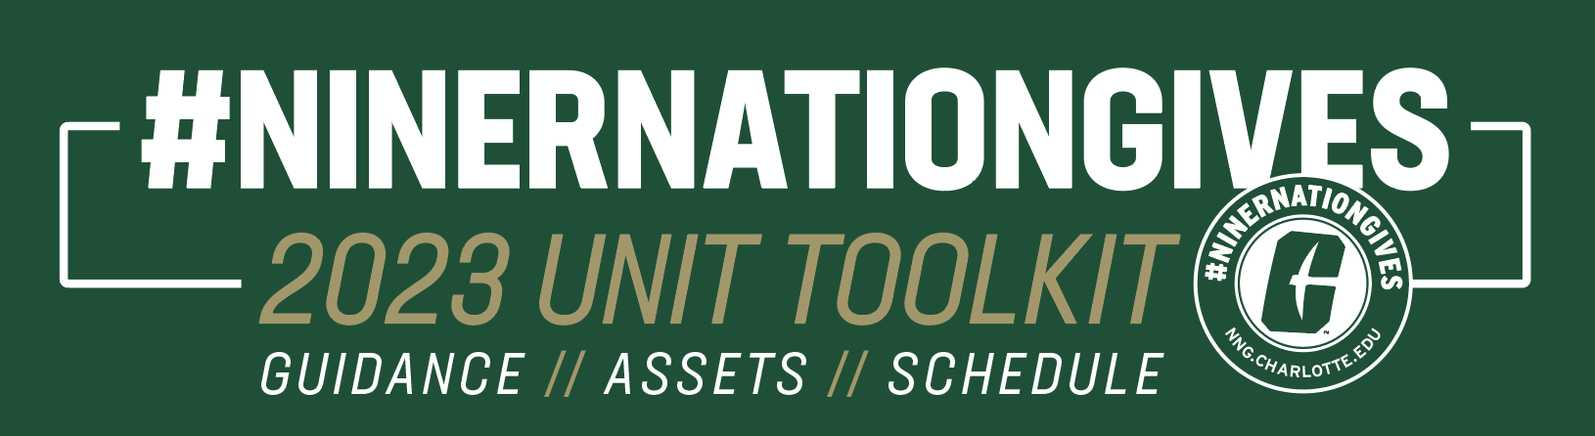

As a college, unit, department, or office affiliated with UNC Charlotte, your role in telling the UNC Charlotte story via social media is vital during #NinerNationGives. Please reference the guidelines below that will be helpful in bolstering that presence.

AVAILABLE ASSETS + IMAGERY

PROFILE IMAGERY
- Profile Image
- Cover photos (FB + TW)

GENERAL/NON-SPECIFIC
- General campaign promotion
- Event promotion
- Challenge
  - Challenge announcement
  - Challenge update
  - Challenge unlocked/complete
- Graphic overlays
- 8.5x11 Printables (for use in photos)

UNIT SPECIFIC
Click here to access the folder specific to your college/unit. Within each folder, you’ll find:
- Support ‘college/unit’
- ‘College/unit’ challenge graphics
  - ‘College/unit’ challenge announcement
  - ‘College/unit’ challenge update
  - ‘College/unit’ challenge unlocked/complete
- Thank you graphic (custom imagery per college/unit)

Note: This folder contains all of the above unit-specific graphics that are intentionally blank for if departments or subunits wish to customize the graphics for their purposes.

APPLYING PROFILE ASSETS

- Please update your profile image no sooner than Tuesday, March 28 and please revert back to your original profile image no later than 5PM on Friday, March 31.
  - A helpful tip from year’s past: Before changing your profile image to the NNG logo, save your current profile image to your desktop to more easily revert back to the original after the campaign.
- Please also note that the headers per platform are different sizes, so be sure to navigate to the appropriate folder to select the correct header per platform.
- When uploading the profile image, the social media platform may prompt you to zoom in on the image for an optimal fit. Please ensure that the circle of the NNG logo aligns with the circle that will become the visible portion of your profile image. The below screenshots represent 1) the file that will be uploaded, 2) how it will look when uploaded before zooming, and 3) the correct fit after zoom.

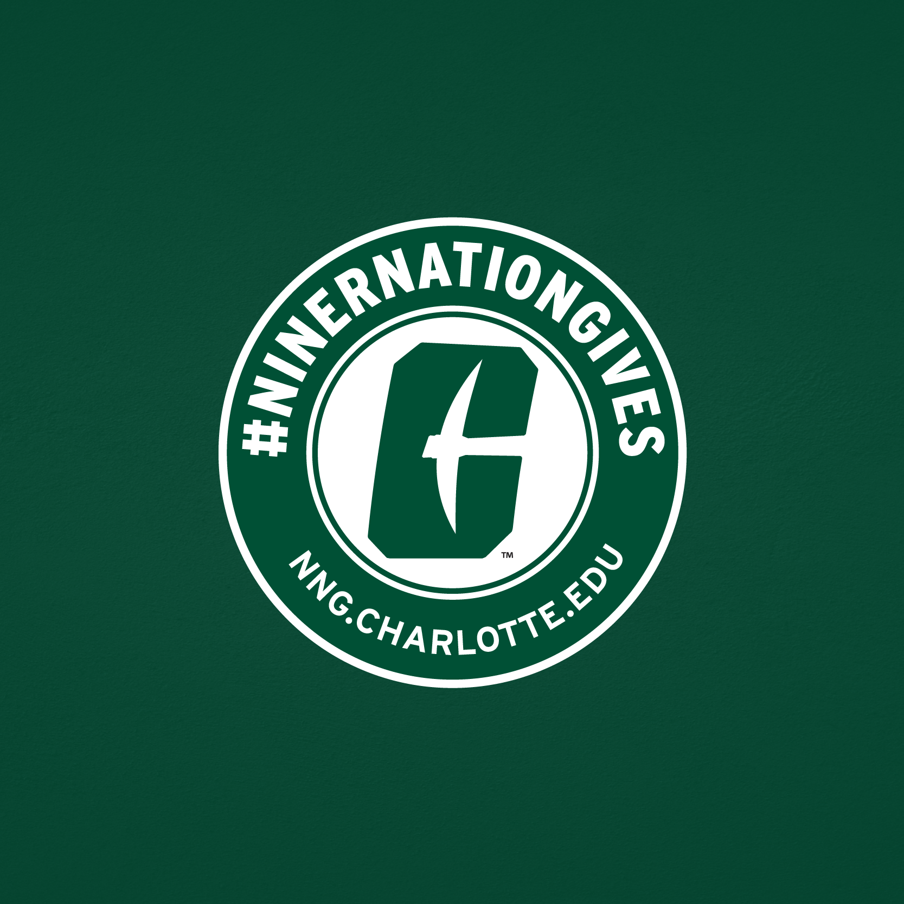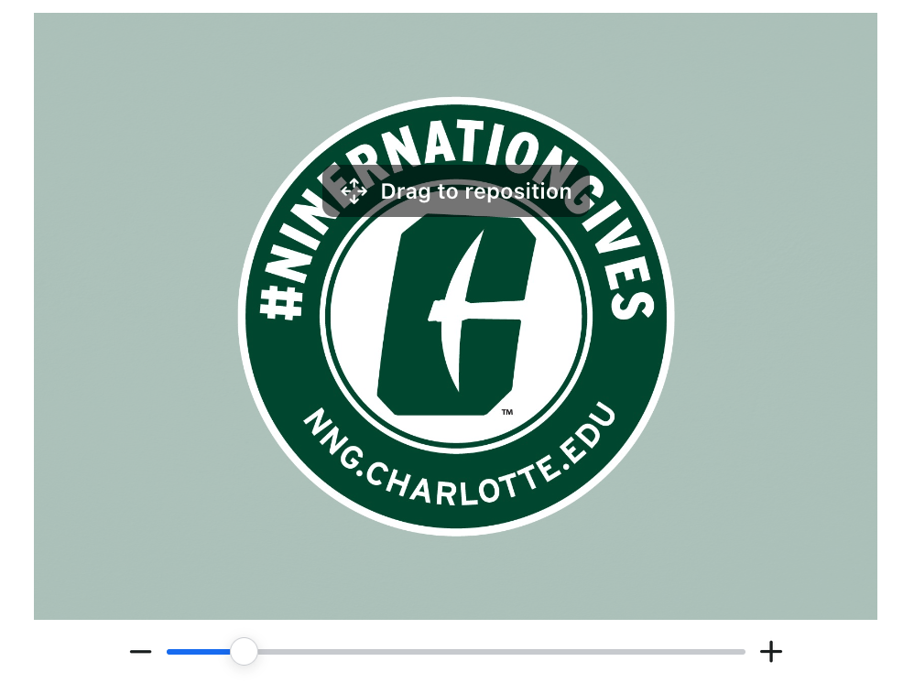

CONTENT + ENGAGEMENT OPPORTUNITIES

CONTENT SCHEDULE
Please visit this document for a built-out content schedule, complete with:
- Suggested posts, imagery, and social copy (COLLEGE/UNIT TAB)
- Opportunities for real-time content creation during the 49 hours (COLLEGE/UNIT TAB)
- Posts to share from the UNC Charlotte social media channels (SHARE FROM @UNCCHARLOTTE TAB)

PER UNIT TAGGED LINKS
This tagged link should be used any time you are driving traffic back to your unit’s page, no matter which platform you’re sharing on.

- CLAS: Coming soon
- COA+A: Coming soon
- Engineering: Coming soon
- COED: Coming soon
- CHHS: Coming soon
- CCI: Coming soon
- BCOB: Coming soon
- Professional Studies: Coming soon
- SDS: Coming soon
- Graduate School: Coming soon
- Student Affairs: Coming soon
- Atkins Library: Coming soon
- Athletics: Coming soon
- Alumni Engagement: Coming soon
- Honors College: Coming soon

CONTENT RELATED FAQ’S
- What hashtag should I use? #NinerNationGives
- What accounts should I tag? @unccharlotte, @49erAlumni (where applicable)
- What emojis can I add for extra Niner Pride?
- How do I find UNC Charlotte-themed Instagram Story stickers?
  - Take a photo or video on Instagram Stories.
  - Tap the smiley-face in the top right-hand corner.
  - Search “UNC Charlotte”
  - Choose your favorite UNC Charlotte sticker to be added to your story
- How do I add a link to my Instagram Story?
  - Take a photo or video on Instagram Stories.
  - Tap the smiley-face in the top right-hand corner.
  - Search “link”
  - Tap the “ 🔗 link” sticker
  - Insert your custom tagged URL (see list below)
  - Preview your URL before hitting “done” to ensure accuracy.
  - How to add an Instagram Sticker or a link to your Instagram Story
- What are some ideas for engaging with users during NNG?
  - Comments and responses are the types of engagement that boosts content’s quality value in the social media algorithms. Engage with and respond to people who comment on your content for it to be shared with more people.
- What if a user comments negatively about the campaign?
  - Please do not engage with commentary that is negative in nature regarding #NinerNationGives. If you would like to pass concerning commentary along to the social media team, please email a link to alliekuenzi@uncc.edu for us to monitor.
- What if I have an urgent social media question during the 49 hours?
  - Please don’t hesitate to reach out to Allie Kuenzi at alliekuenzi@uncc.edu if you have any real-time questions.

