April 4, 2024

Dr. Xiaoxia Newton
President of the Faculty

Re: Motion to Award Degrees

Dear Xiaoxia:

It is the time in the semester to place the motion to award degrees on the Faculty Council agenda. Thank you.

MOTION TO AWARD DEGREES

I move that, consistent with the Board of Trustees’ Resolution on May 5, 1980, the Faculty recommend to the Chancellor that appropriate degrees can be conferred on all candidates who have met the established requirements of the Faculty since December and that the degrees have an award date of May 2024.

Sincerely,

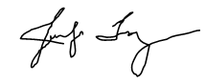
Jennifer Troyer
Provost and Vice Chancellor for Academic Affairs

