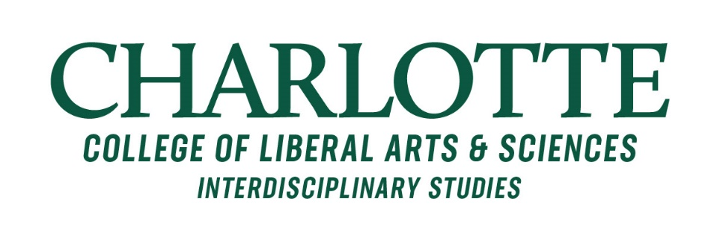
MEMO
To: Provost Joan Lorden
From: Joseph Dippong, Interim Director, MALS
CC: Beth Whitaker, Executive Director, Interdisciplinary Studies
Date: October 20, 2022
Subject: Proposed Program Name Change for MA in Liberal Studies

I am writing to initiate the process of changing the name of the MA in Liberal Studies (MALS) to the MA in Interdisciplinary Studies (IDST). The proposed name change will align the program more with other existing structures and programs at UNC Charlotte and will assist in recruiting more students and expanding the program. In what follows, I briefly outline the most substantial reasons for the proposed name change.

First, CLAS has recently launched a BA in Interdisciplinary Studies, which is essentially the undergraduate counterpart to the MALS program. Not only is Interdisciplinary Studies a more accurate description of the educational underpinnings of the graduate program, changing MALS to MA in Interdisciplinary Studies will create a clear connection between our undergraduate and graduate programs. We even plan to use the same prefix (IDST) for courses in the two programs. This connection will serve two purposes: a) it will open a pipeline from the BA in Interdisciplinary Studies to the graduate program; b) it will open the door to initiating an early-entry program that will allow the MA program to recruit top students from the undergraduate major. Taken together, the name change has the potential to increase the visibility of and enrollment in our interdisciplinary graduate program.

Second, in 2021-22, MALS underwent an external review, and the external reviewer specifically noted issues of program identity. In the “challenges” section of the review, Dr. Michael Garval from NC State University noted that “[the] program name (Master of Arts in Liberal Studies or MALS)… does not resonate with prospective students; with present student or alumni’s family, friends, and professional contacts; or, with current and potential partners across campus and in the community.” Although it may seem like a small matter on paper, having a program name that stakeholders can “get behind” is essential to establishing a strong program identity. Accordingly, the external review recommended that we move forward with changing the program name to MA in Interdisciplinary Studies “as soon as possible.”

Third, and somewhat related to the points raised above, the degree of faculty engagement with MALS is quite low compared to what we see with other interdisciplinary programs. I have observed this since I first became involved with MALS three years ago, and the point was also raised in the recent external review. One hinderance to increasing faculty engagement, I believe, is that many faculty members do not know the program exists (and many of those that do know the program exists have no idea what we do). This is at least in part a branding
issue. Given the newly launched BA in Interdisciplinary Studies and the establishment of the Office of Interdisciplinary Studies, it seems likely that aligning the MALS program with these structures can help raise faculty awareness, knowledge, and engagement.

Finally, it should not be overlooked that the word “mals” in Spanish means “bad.” With an increasing number of Spanish-speaking students and faculty at UNC Charlotte, dropping the MALS name will assist our ongoing efforts to attract students from diverse backgrounds to the program and the university more widely.

In sum, I propose changing the name of the MA in Liberal Studies to the MA in Interdisciplinary Studies. Such a change has potential positive impacts for recruiting, developing a clearer program identity, and increasing faculty engagement and involvement with the program.

